Project Design Phase
Solution Architecture

Date | 13 July 2026
Team ID | SWTID-2026-9658
Project Name | Customer Registry
Maximum Marks | 4 Marks

Solution Architecture:
1. Architectural Overview & Business Alignment
The solution architecture is designed to bridge the gap between untracked customer issues and active resolution by establishing a secure, scalable, and responsive MERN (MongoDB, Express, React, Node.js) Stack application. The architecture replaces manual tracking or "black box" email systems with a real-time, event-driven data flow.
2. Software Structure & Tiered Components
The Customer Care Registry is structured into three primary architectural layers:
A. Presentation Layer (Frontend - React.js)
- Characteristics: A single-page application (SPA) that acts as the user interface. It features a responsive layout designed for both desktop and mobile viewports.
- Core Views:
  - Customer Portal: Ticket submission forms with input validation and a personal status tracking history log.
  - Agent Dashboard: A centralized ticket queue with robust search, filter, and status modification controls.
B. Application & Logic Layer (Backend - Node.js & Express.js)
- Characteristics: A RESTful API backend that processes requests from the presentation layer and communicates with the database.
- Core Controller Modules:
  - User Authentication Controller: Manages secure user login, registration, and role-based access control (Customers vs. Support Agents).
  - Ticket Controller: Handles validation logic, creation, updates, and database retrieval queries for support complaints.
C. Data Layer (Database - MongoDB)
- Characteristics: A flexible, document-based non-relational database used to store application records.
- Core Collections:
  - Users Collection: Stores credentials, roles, and profile details.
  - Tickets Collection: Stores ticket IDs, customer IDs, detailed descriptions, attachments, status states (e.g., Pending, In Progress, Resolved), and update timestamps.
3. Data Flow and System Behavior
To define how the solution behaves, the system processes a customer complaint through the following structured data path:
Plaintext
[Customer UI] --(1. Submits Ticket Form via HTTPS POST)--> [Express Router]
│
(2. Server-side Validation)
│
[MongoDB Database] <--(4. Commits Document)-- [Ticket Controller / Mongoose]
│
(5. Returns Created Status)
│
[Customer UI] <--(6. Displays Real-time Success State & Ticket Log Updates)

- Submission: The user submits a structured complaint form via the React frontend.
- Routing: The presentation layer sends a secure HTTPS POST request containing the ticket payload to the Node/Express backend.
- Authentication & Validation: The backend validates the user's session token and verifies that the ticket fields meet database schema criteria.
- Data Persistence: The validated ticket data is sent to the MongoDB instance and written to the Tickets collection.
- Confirmation: Once committed, MongoDB sends a confirmation response back to the Express server, which responds with a 201 Created HTTP status code.
- UI Refresh: The React interface immediately updates the customer's dashboard feed with their new ticket details, eliminating user anxiety.
4. System Specifications & Non-Functional Requirements
- Security: JSON Web Tokens (JWT) are implemented in the Express backend to secure client-to-server communications and ensure role authorization.
- Scalability: The horizontally scalable nature of MongoDB's document architecture ensures the system can seamlessly handle spikes in concurrent ticket submissions.
- Responsiveness: The React client-side routing model provides near-instant page transitions and ticket search filtration without requiring full browser reloads.

Solution Architecture Diagram:

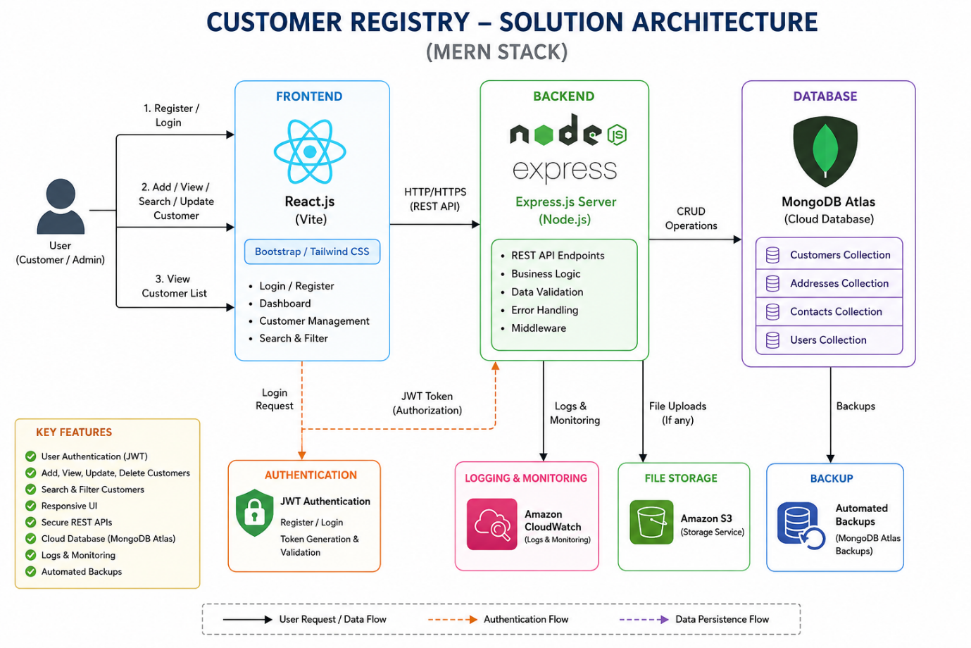
Figure 1: Architecture and data flow of the customer Registry

